**Database Management Systems**

**Course code: CS/AI 3103**

**Assignment -7**

**Note: In this assignment along with question the desired output is given if you are not getting the desired output then your sql query might be wrong. Check the output you get with the desired output.**

**Instructions to open mysql and using created database**

1. **Start mysql using**

$ mysql -u root –p

(enter password if prompted)

1. **Use database inside which you have created and store the tables given in the assignment-1**

use studentdb;

1. **Use the following table created in assignment-1 to solve this assignment**

Student (snum, sname, major, standing, age)

Faculty (fid, fname, deptid)

Class (name, meets, room, fid)

Enrolled (snum, cname)

1. **Use the following employee table of assignment 4 to solve this assignment**

Employee(empid, empname, department, salary, bonus, hiredate date, currentdate date, EDOB date);

|  |  |  |  |  |  |  |  |
| --- | --- | --- | --- | --- | --- | --- | --- |
| **empid** | **empname** | **department** | **salary** | **bonus** | **hiredate** | **currentdate** | **EDOB** |
| 1 | Mark | HR | 30000 | 6000 | 2008-09-21 | 2022-10-03 | 1990-01-02 |
| 2 | Miraj | Admin | 25000 | 5000 | 2019-10-02 | 2022-10-03 | 1982-10-17 |
| 3 | Chinaya | HR | 50000 | 9000 | 2008-09-21 | 2022-10-03 | 1984-03-03 |
| 4 | Dilkush | Admin | 25000 | 6000 | 2022-10-19 | 2022-10-03 | 1980-10-21 |
| 5 | Eimanual | Account | 10000 | 4000 | 2020-08-12 | 2022-10-03 | 1983-12-19 |
| 6 | Fisal | Account | 12000 | 7000 | 2008-09-21 | 2022-10-03 | 1980-05-21 |
| 7 | Girkshan | HR | 55000 | 12000 | 2015-07-05 | 2022-10-03 | 1992-09-14 |
| 8 | Milka shingh | HR | 58000 | 10000 | 2016-09-15 | 2022-10-03 | 1990-09-15 |

**Queries: Exercise on sub query:**

Note : There is not any general syntax for sub queries. However, sub queries are seen to be used most frequently with SELECT statement as shown below:

SELECT column_name FROM table_name WHERE column_name expression operator (SELECT COLUMN_NAME from TABLE_NAME WHERE ... );

1. Subquery in WHERE Clause

Syntax: SELECT column_name(s)

FROM table_name_1

WHERE column_name expression_operator{=,NOT IN,IN, <,>, etc}(SELECT column_name(s) from table_name_1 or table_name_2);

1. Write the SQL query to display department with maximum salary from employee table using subquery.

Desired output:

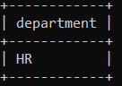

**Solution: select department from employee where salary=(select max(salary) from employee);**

1. Write the SQL query to find the name and id of the employee with minimum salary in the employee table using subquery.

Desired output:

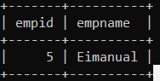

**Solution: select empid, empname from employee where salary=(select min(salary) from employee);**

1. Write the SQL query to find the employees whose salary salary is more than the average salary earned by all employees using subquery.

Desired output:

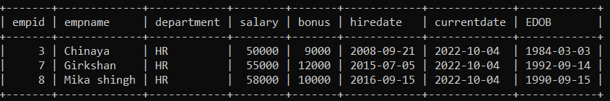

**Solution: select *from employee where salary>(select avg(salary) from employee);**

1. Write the SQL query to find the employees who earn the highest salary in each department using subquery.

Desired output:

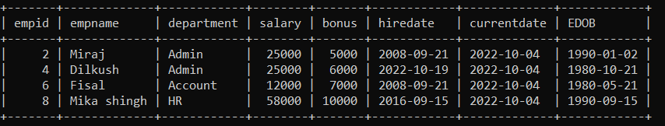

**Solution: select *from employee where (department,salary) IN (select department,max(salary) from employee group by department);**

1. Write the SQL query to find the employees in each department who earn the more than the average salary in that department.

Desired output:

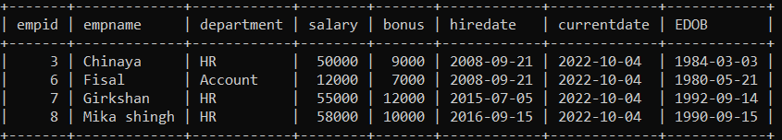

**Solution: select *from employee e1 where salary>(select avg(salary) from employee e2 where e2.department=e1.department);**

1. Write the SQL query to find the id, name, department, and salary of the employee with the second highest salary from employee table using subquery.

Desired output:

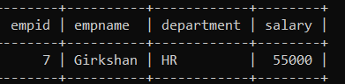

**Solution: select empid, empname, department, salary from employee where salary=(select max(salary) from employee where salary<(select max(salary) from employee));**

1. Write the SQL query to find the employee id of all the employees that contain an employee id for which the salary is greater than the salary of any one of the employees in employee id 2.

Desired output:

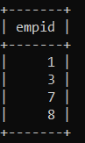

**Solution: select distinct empid from employee where salary>ANY(select salary from employee where empid=2);**

1. Subquery in HAVING Clause

Syntax: SELECT column_name(s)  
 FROM table_name_1  
 WHERE condition  
 GROUP BY column_name(s)  
 HAVING Aggregate_function(column_name)expression_operator{=,  
 <,>}(SELECT column_name(s) from table_name_2);

1) Write the SQL query to find the names of all classes that either meet in R128 or has more than five students enrolled.

Desired output:

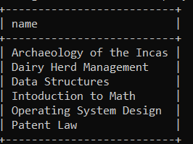

**Solution: select name from class as c1 where room='R128' or (select count(*) from enrolled,class where class.name=enrolled.cname group by name having class.name=c1.name)>5;**

2) Write the SQL query to find the names of students who enrolled in the maximum number of classes.

Desired output:

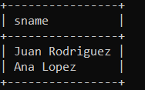

**Solution: select distinct s.sname from student s where s.snum in(select e.snum from enrolled e group by e.snum having count(*)>=all(select count(*) from enrolled e2 group by e2.snum));**

3) Write the SQL query to find the age of the oldest student who is either a History major or enrolled in a class taught by Ivana Teach.

Desired output:

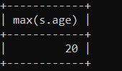

**Solution: select max(s.age) from student s where (s.major='History') OR s.snum IN (select e.snum from class c, enrolled e,faculty f where e.cname=c.name and c.fid=f.fid and f.fname='Ivana Teach');**

1. Write the SQL query to find the names of all students who are enrolled in two classes that meet at the same time.

Desired output:

**Empty set**

**Solution: SELECT DISTINCT S.sname FROM Student S**

**WHERE S.snum IN (SELECT E1.snum FROM Enrolled E1, Enrolled E2, Class C1, Class C2 WHERE E1.snum = E2.snum AND E1.cname <> E2.cname AND E1.cname = C1.name AND E2.cname = C2.name AND C1.meets = C2.meets);**